Final Report
  - Winter 2011 Groups
October 1, 2011

Baseline Characteristics of Participants
In February 2011, 33 employees of Albemarle County enrolled in the Medically Supervised Weight Loss (MSWL) program; 73% were Albemarle County School employees and 55% were teachers. Their baseline characteristics are as follows:
Initial Body Mass Index (kg/m²):
 | 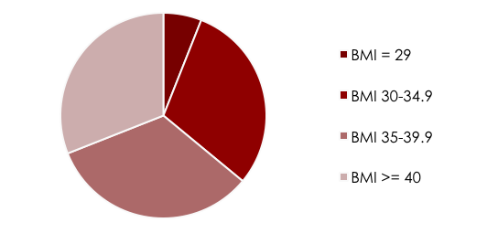
   | Percent in BMI Category
  Overweight, 25- 29.9 | 6%
  Obesity, Grade I (30-34.9) | 30%
  Obesity, Grade II (35-39.9) | 33%
  Obesity, Grade III (Morbid Obesity, > 40) | 31%

Health Conditions

Top 5 Health Conditions of Participants
Health Condition | % Participants
High Blood Pressure | 50%
High Cholesterol | 47%
Difficulty breathing while sleeping or Sleep Apnea | 38%
Pre-Diabetes or Diabetes | 27%
Asthma | 12%

Initial Anthropometric and Laboratory Values

Antropometric/Lab | Average Initial Value | Commentor Normal Range
Weight | 234 lb
Body Mass Index (kg/m²) | 37.4 | Grade II Obesity
Waist Circumference | 44 inches | High Risk WC
Neck Circumference | 16 inches
Percent Body Fat | 45.8% of total body weight | High risk
Hemoglobin A1c | 6.8% | Nondiabetic: < 6.0 Goal for diabetic: < 7%
Total Cholesterol | 195 mg/dL | Nl: 0-200
Fasting Triglyceride | 149 mg/dL | Nl: 0-150
LDL | 112 mg/dL | Above optimal
HDL | 53 mg/dL | 40-60
LDL/HDL Ratio | 2.2

Initial Activity and Inactivity Level

Initial Dietary Scores
Scale 0 to 100 (100 indicating a healthy dietary score)

Comparison to Previous Year/Groups

Weight: More participants in Grade I Obesity entered the program with a concomitant decrease in the morbid obesity group. The average weight was approximately 20 pounds lighter this year compared to last. Waist circumference, neck circumference and body fat content is accordingly lower than the previous year.
Health Conditions: Compared to last year, hypertension and high cholesterol continue to be the most prevalent health conditions of MSWL participants. The prevalence of pre and overt diabetes among participants is relatively stable but more participants with sleep apnea and reports of difficulty breathing while sleeping enrolled in the program this year compared to last year (increased 9% this year, surpassing diabetes & pre-diabetes).
Laboratory Measures: Baseline, average blood glucose and fasting lipid panels were within normal limits but individually, 33% had hypercholesterolemia, 33% hypertriglyceridemia, 45% high LDL and 30% with low HDL; 48.5% of participants had metabolic syndrome. The average HbA1c among participants with diabetes was 7.1%.
Physical activity and Inactivity: Baseline physical activity was similar to previous years and was low. A new tool to measure physical inactivity was used this year which is more comprehensive than last year’s tool so no comparison can be made.
Dietary Intake: Baseline dietary scores are similar to last year.

Name: Patsy Reardon

Participant Spotlight
Workplace: Stone-Robinson Elementary School
Years working with Albemarle County 35
Pounds lost on MSWL: 50 lbs and continuing to lose!

What did you gain from the MSWL program? Through the MSWL program, I learned how to make food work for my body so that I am in control of food and food is not in control of me. Having a nutritionist and a personal trainer helped me focus on what I haven’t done well, what I need to do well, and instilled a belief and confidence in me that I have never had before.
How is this program different than what you have done in the past to lose weight? This program is different because it’s not just about making healthier choices. It makes you really think about the choices you have made and questions why you made those choices. I got a much clearer understanding of my relationship with food and as a result, I have made lifestyle changes that are really working for the betterment of my overall health and well-being. I am much more accountable to myself now.
How did you surprise yourself? My biggest surprise was how much I could do physically. My trainer Zach believed in me long before I believed in myself. He gave me challenges that were out of my comfort zone and I met the challenges. That has really boosted my self- confidence. Nutritionally, my biggest surprise was the power of protein and the reality of making good food that is good for me! The best surprise is that my target clothes are now too big!!! I am still continuing to lose weight and working out is now a habit I don’t want to quit.
What would you like to tell Albemarle County (your employer) about the program? I would like to say thank you from the bottom of my heart for offering this program. It has been a wonderful, life changing experience and I am a healthier, happier, more confident person for having had this experience.

Results

Retention: 97% completed the program. Participation was 100% the first three months. While there was only one official drop out, there were six participants that were not actively engages from months 4 to 6. The retention and participation rate remain high as compared to most weight management programs that have a 50% retention by program end.

Participation
Overall Retention | 97%
Active Participation mos 0-3 | 100%
Active Participation mos 4-6 | 79%

Attendance

MSWL Component |  | % Attendance
One-on-One RD visits and follow-up | 86%
Group Classes | 78%

Participant Satisfaction

MSWL Component | Average Score (1-5 scale, 5 highest)
Overall Rating of Program | 4.4
RD Individual Sessions | 4.9
Group Classes | 3.9
MD Initial Evaluation | 4.0
Personal Trainer | 4.3
PREP | 3.7
Overall ACAC Experience | 4.5

Overall Anthropometric and Laboratory Changes

Antropometric/Lab | Avg Initial Value | Avg Change
Weight | 234 lb | -16.4 lb (7.0% loss from initial weight)
Waist Circumference | 44 inches | -2.32 inches
Neck Circumference | 16 inches | -0.5 inch
Percent Body Fat | 45.8% | -4.3%
Hemoglobin A1c | 6.8% | -0.54%
Total Cholesterol | 195 mg/dL | -11 mg/dL
Fasting Triglyceride | 149 mg/dL | -31.6 mg/dL
LDL | 112 mg/dL | -20 mg/dL
HDL | 53 mg/dL | +2.6 mg/dL
LDL/HDL Ratio | 2.2 | -0.34

Pre-Diabetes and Diabetes- Glucose Control

Health Condition | n | Beginning Hb_{A1C} | Ending Hb_{A1C} | Change
Diabetes | 7 | 7.1% | 6.6% | -0.7%
Pre-Diabetes | 2 | 5.9% | 5.7% | -0.2%
Family members lost an additional 100 lbs.

Group Weight Changes

35% of participants lost > 10% of their initial
body weight
Individual Weight Changes of all Participants
Pounds

Name: Anna Snyder

Participant Spotlight
Workplace: Mary C Greer Elementary School
Years working with Albemarle County: 4th year
Results: 7.4% body fat loss and a 73% increase in physical activity

What did you gain from the MSWL program? Confidence, sense of self worth.

How is this program different than what you have done in the past to lose weight? I felt supported the entire time I was in the program. When I lost weight, gained weight or plateaued…I was always supported.

How did you surprise yourself? I pushed myself harder because this was something I wanted to do for me and for no one else.

What would you like to tell Albemarle County about the program? It is the best gift that they could have given me. It is not really a tangible gift. It’s one where I was able to identify what I really needed and wanted in terms of improving my health. It says a lot about an employer to give their employees the opportunity to improve and empower themselves. Albemarle County cares enough about the people representing them and they saw a need to help. I am a healthier person, both physically and mentally. I am a better teacher, colleague, friend and daughter. I am forever indebted and so appreciative of the chance to do something for me.
Inactivity and Physical Activity Changes
uis mauris id sapien venenatis semper. Aenean est.
Physical Inactivity
by 2.5 hours/day

Physical Activity increased by 32%

Dietary Changes
- 17% improvement in Behavioral Eating
- 17% improv’t in fruit, vegetable & fiber intake
- 16% reduction in high fat foods
- 12% reduction in caloric drink intake

- 13% improvement in Overall Dietary Score

Changes in Health Related Quality of Life

Vitality
General
Health

Bodily Pain
Mental
HR QOL
Physical
HR QOL

Summary

Participants in the 2011 MSWL groups did equally as well as previous MSWL groups in regards to weight loss, waist circumference changes & dietary changes. The average loss of 7% is equal to the last round and better than the Diabetes Prevention Program, which was shown to reduce the incidence of type 2 diabetes by 58%. In this group, there were seven people with diabetes and two people with diagnosed pre-diabetes. The participants with diabetes lowered their Hb_{A1c} by 0.7% and participants with pre-diabetes lowered it by 0.2% and continued to prevent the onset of this condition.

Participants in this group were much more engaged in physical activity and lost a larger percent of their body fat compared to our last session in 2010. In fact, there were 3 people who lost more body fat than weight indicating they built lean body mass while losing weight (very challenging to accomplish). Their health related quality of life was more improved than previous years in the Mental Health and Vitality domains, perhaps, in part, due to regular physical activity. We made some changes to the personal trainer aspect of the program and given the participant’s results, their satisfaction with ACAC and the personal trainers, the changes appear to have made a difference.

Participant satisfaction wwith different components of the program was similar to 2010 except their was increased satisfaction with their MD experience, Personal Trainers and the overall ACAC experience. PREP,which was added this year, had an average rating of 3.7, however, ACAC has identified the problems and we have met and anticipate a better experience in the Fall 2011 groups.

Participant Spotlight

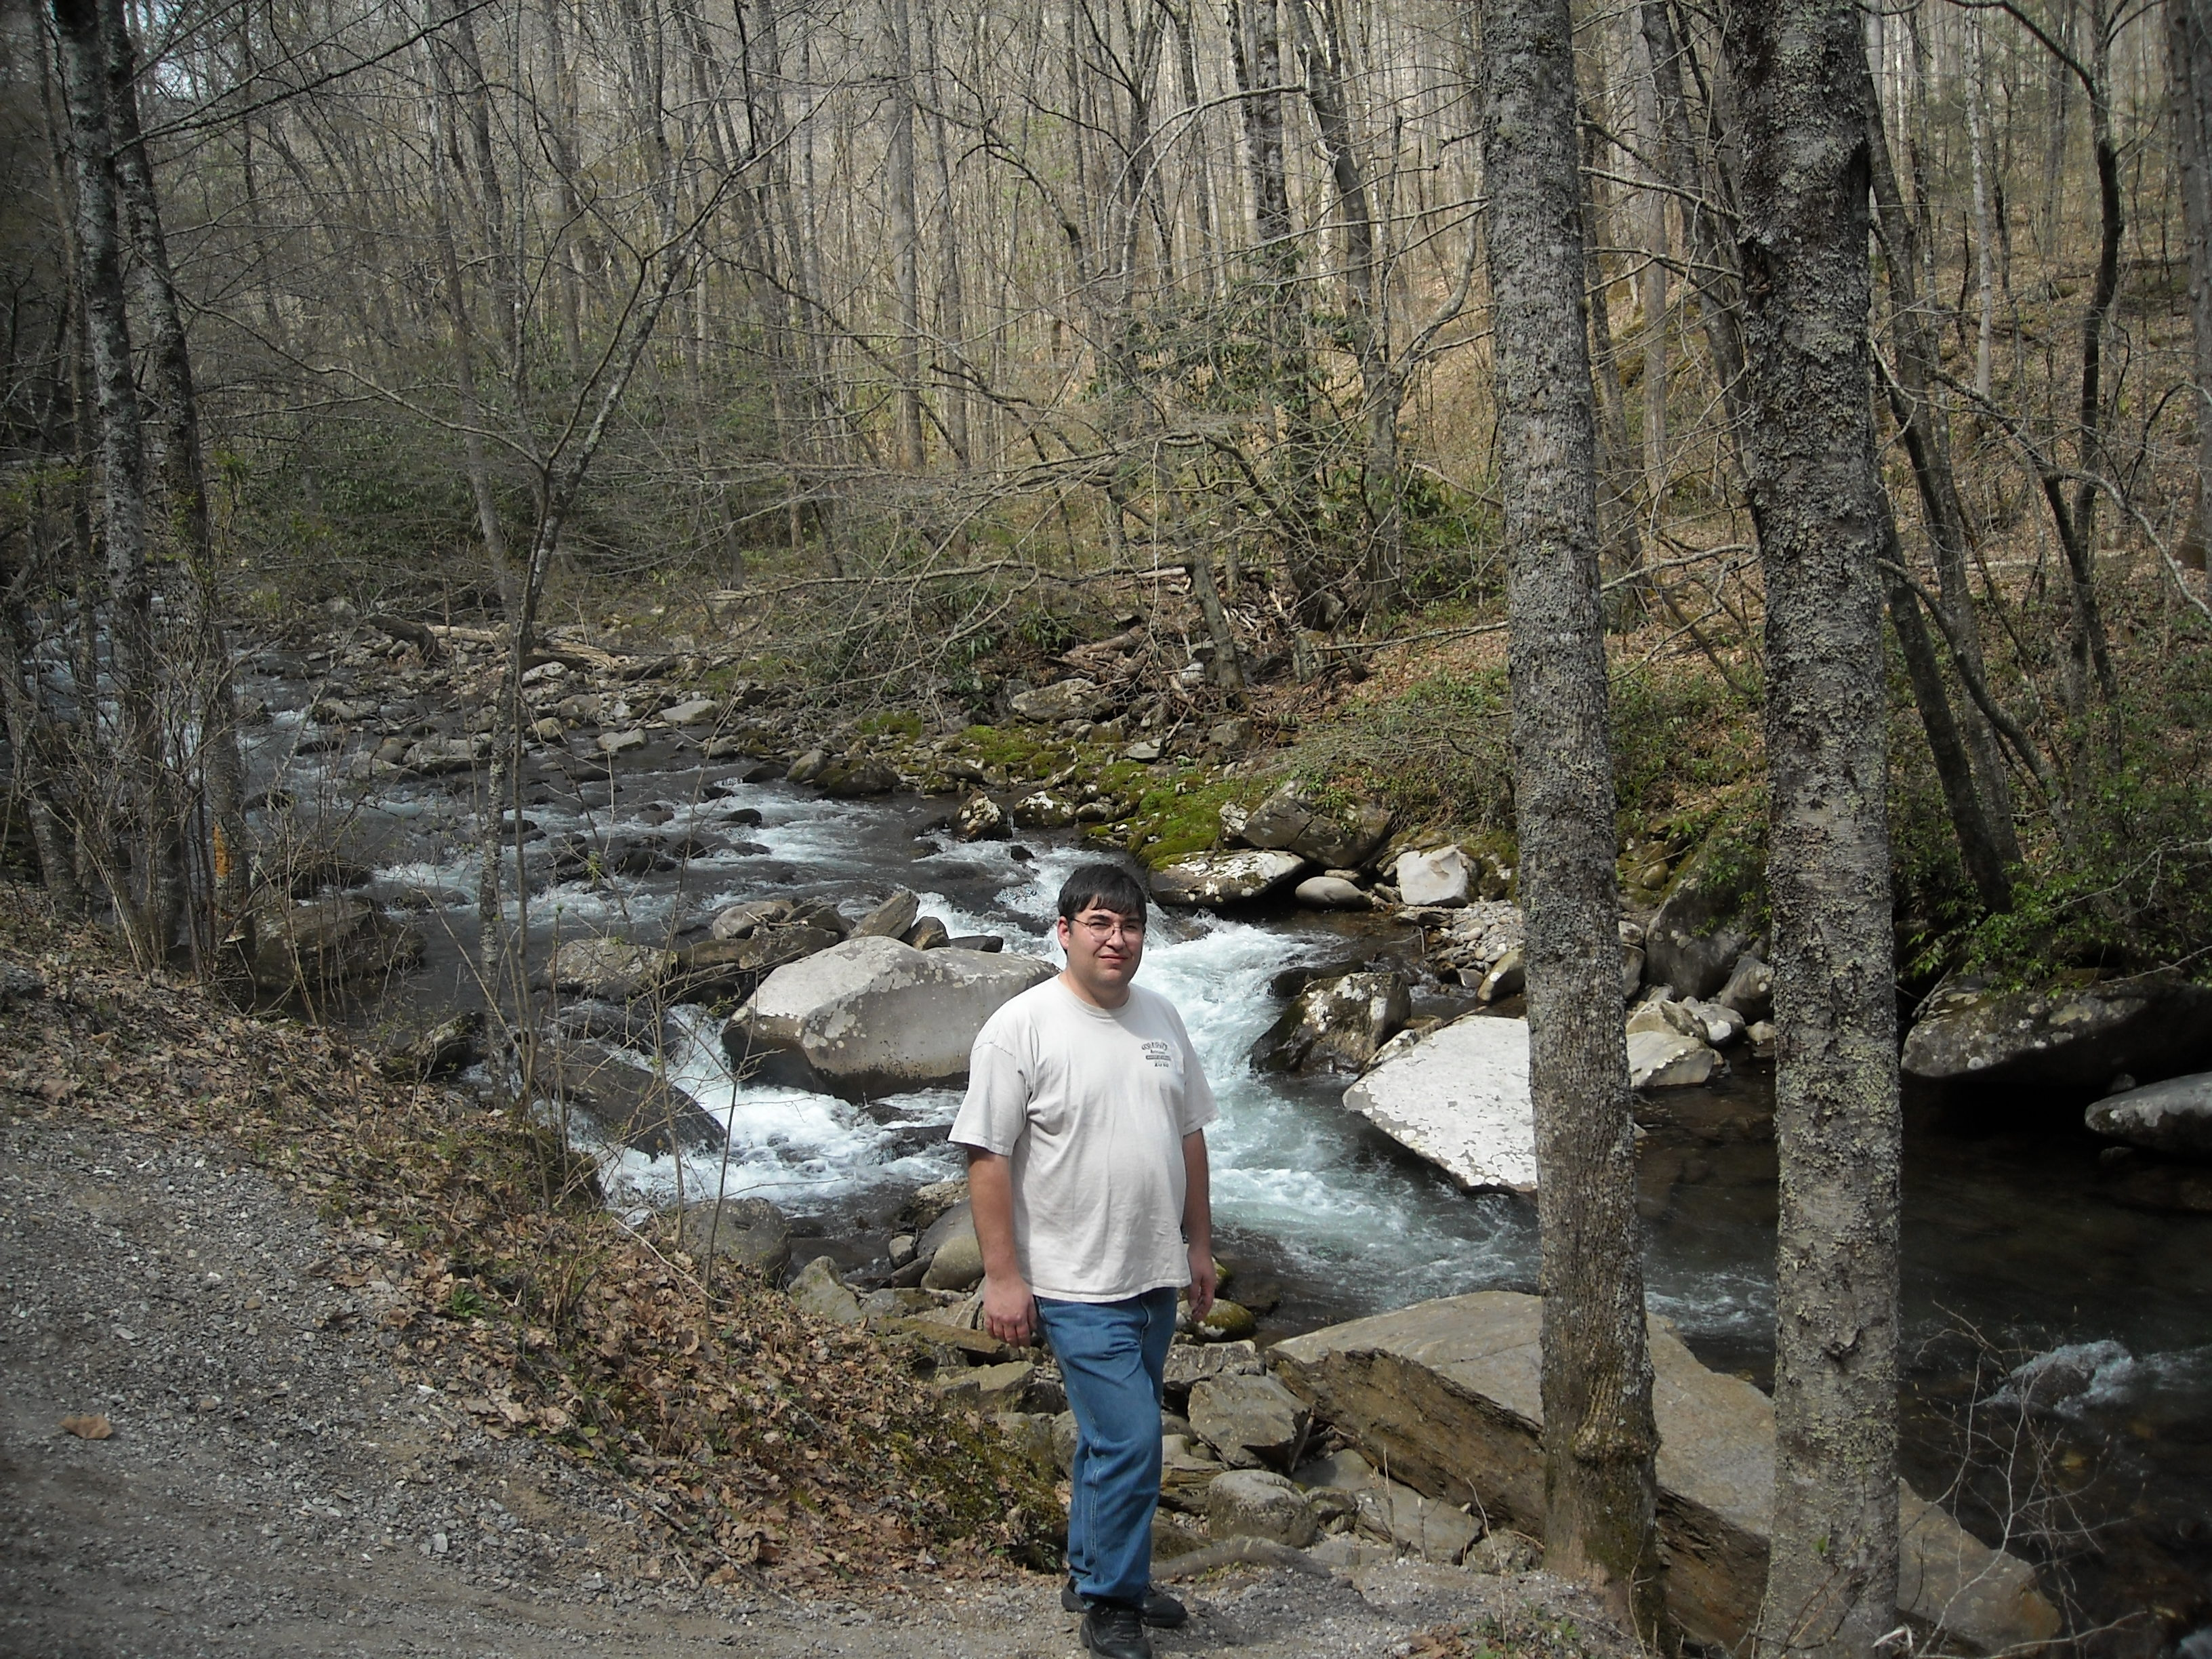

Glynn Baker
Baker-Butler Elementary
19 yrs with Albemarle Co.
Lost 4 inches from his waist. Increased his HDL (good cholesterol) by 19 points

How did you surprise yourself? The thing that surprised me the most is how I was able to eat more foods that were better for me, and cut way back on the bad stuff, without too much struggle.

What did you gain from the MSWL program? You don’t have to starve to lose weight. I was given the proper tools help to eat healthy, and feel full. And with the proper amount of activity and exercise, the weight will come off.

What would you like to tell Albemarle County (about the program? This is a great program. I have struggled with weight gain over the last few years, and my health was starting to really decline and was always feeling tired. Thanks to this program I am over 30lbs lighter and have noticed that I have more energy and able to do tasks much more easily now, and is great to here the comments when people have noticed that I have lost weight, and is pushing me to loose more.
I have a family history of Heart disease and Diabetes and I saw myself heading that way, so hopefully with what I have learned I can keep myself free of these diseases
I would like to thank you for offering this program and I hope you keep it going to help others who struggle with weight problem.

